Ideation Phase
Brainstorm & Idea Prioritization Template
Date | 21 October 2026
Team ID | SWUID2026403023
Team Members | Individual project (single member)
Project Name | StaffSync
Maximum Marks
Document Version | v1.2 (revised 27 October 2026; originally issued 21 October 2026 as v1.0)

Brainstorm & Idea Prioritization :
Brainstorming provides a free and open environment that encourages participants to think creatively about a problem. Volume is prioritised over value at first; ideas are then grouped and ranked. This project is an individual project, so the brainstorming was carried out by the project owner, using HR workflows (employee, manager and HR roles) as the source of ideas.
Step-1: Team Gathering, Collaboration and Select the Problem Statement
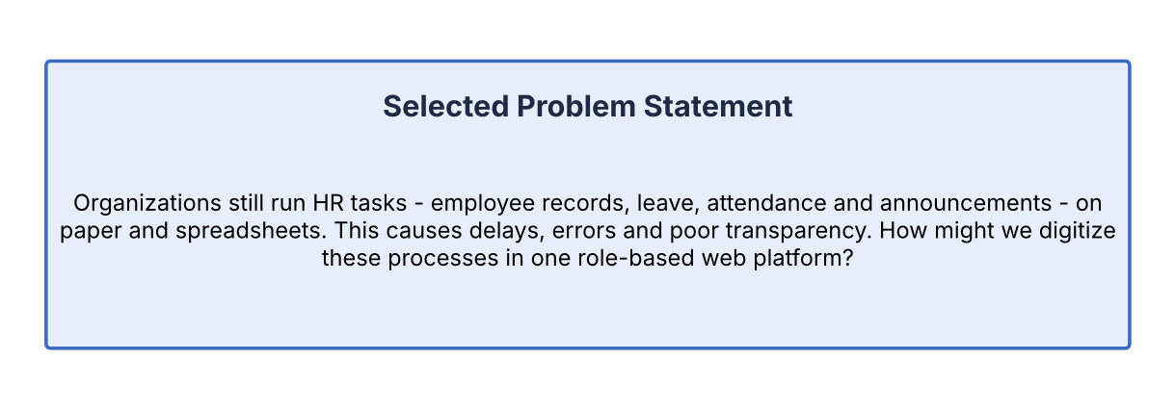
Step-2: Brainstorm, Idea Listing and Grouping
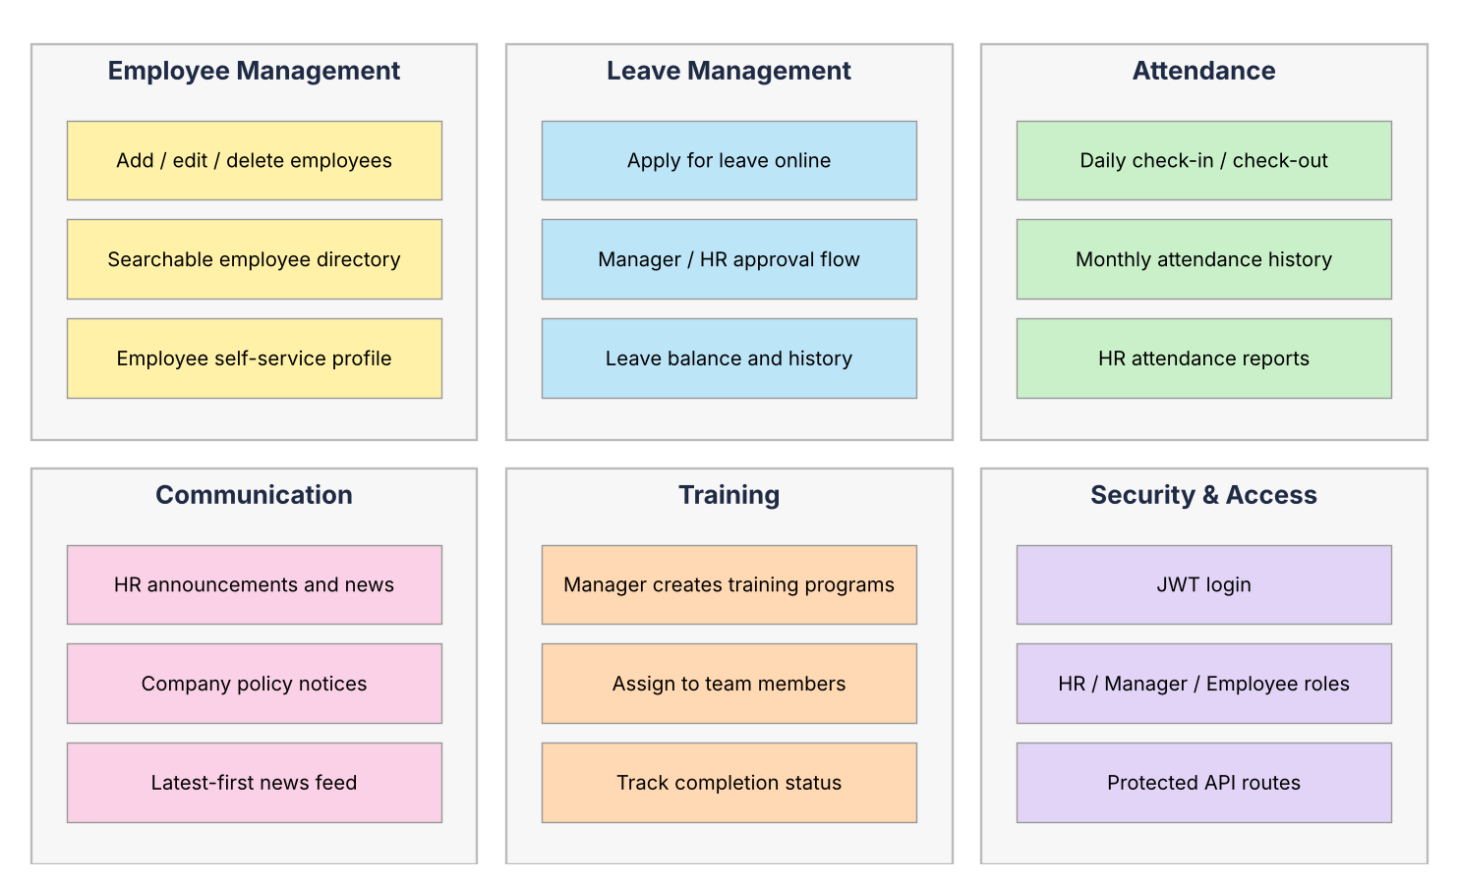
Step-3: Idea Prioritization
- High Impact & High Feasibility (MVP): JWT login with roles, employee management, leave application and approval, attendance marking, announcements
- High Impact & Medium Feasibility: Training and development programs, attendance reports
- Nice to Have / Future scope: Email notifications, payroll module, biometric attendance integration
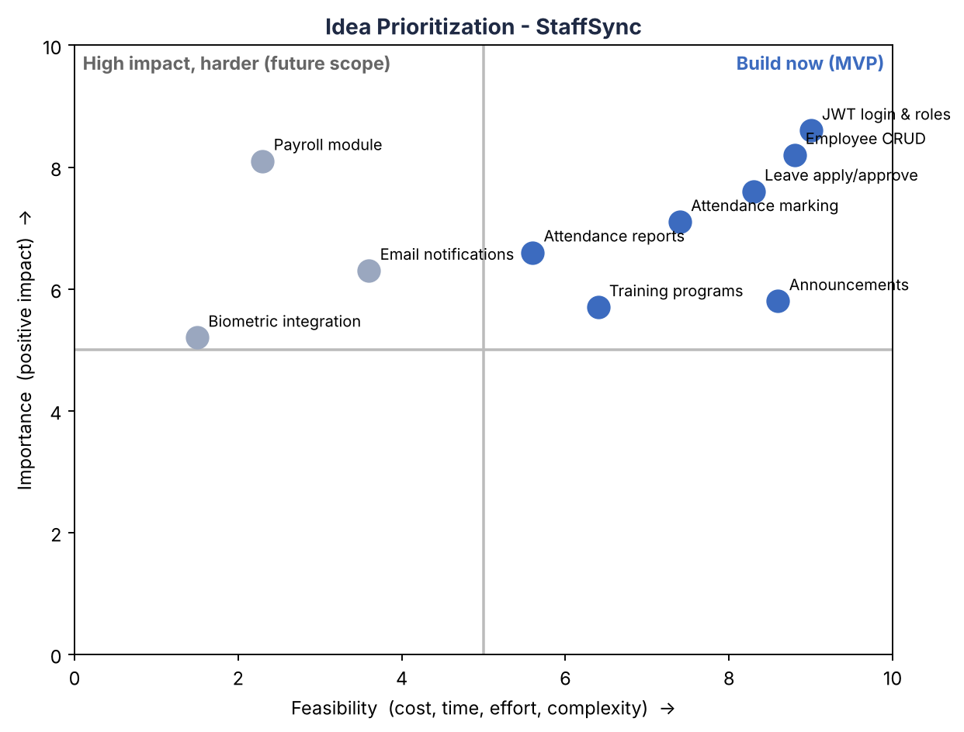
Prioritization Scoring
Each idea was scored by the project owner from 1 to 5 for Impact (value to HR, managers and employees), Feasibility (how achievable it is with the MERN stack in the available time) and Effort (development effort; 5 = highest). Priority score = (Impact x Feasibility) / Effort. Scores are the owner's judgement, not measured data.
Idea | Impact | Feasibility | Effort | Score | Decision
Announcements board | 3 | 5 | 1 | 15.0 | MVP
Employee management | 5 | 5 | 2 | 12.5 | MVP
JWT login with roles | 5 | 4 | 2 | 10.0 | MVP
Attendance marking | 4 | 4 | 2 | 8.0 | MVP
Leave application and approval | 5 | 4 | 3 | 6.7 | MVP
Attendance reports | 3 | 3 | 2 | 4.5 | Medium - after MVP
Training programs | 4 | 3 | 3 | 4.0 | Medium - after MVP
Email notifications | 3 | 2 | 3 | 2.0 | Future scope
Payroll module | 4 | 1 | 5 | 0.8 | Future scope
Biometric attendance integration | 2 | 1 | 5 | 0.4 | Future scope

Decision rule: score 6 or more = MVP; 3 to 5.9 = medium priority; below 3 = future scope. Training programs remain in the delivered scope (Sprint-3 and Sprint-4) because they are a stated requirement of the project, even though the score places them after the core MVP.
Reading the Scores
Because the score divides by effort, low-effort ideas (such as the announcements board) rank highly. The score therefore guides the build order, not the importance of a feature. Employee management, login and leave remain the core of StaffSync because every other module depends on them or on the data they hold.
Revision History
Version | Date | Summary of changes
v1.0 | 21 October 2026 | Initial issue.
v1.1 | 23 October 2026 | Added an explanation of how to read the prioritization scores.
v1.2 | 27 October 2026 | Aligned the project overview and role/module descriptions with the current StaffSync stack and demo deployment; retained detailed design notes and planned-vs-actual distinctions.

